# Water portability

## DNN

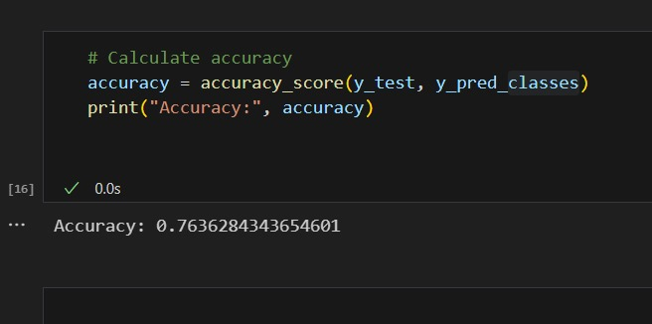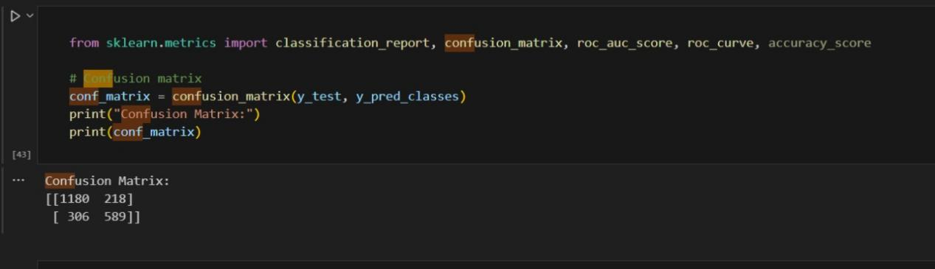

# **Water level prediction**

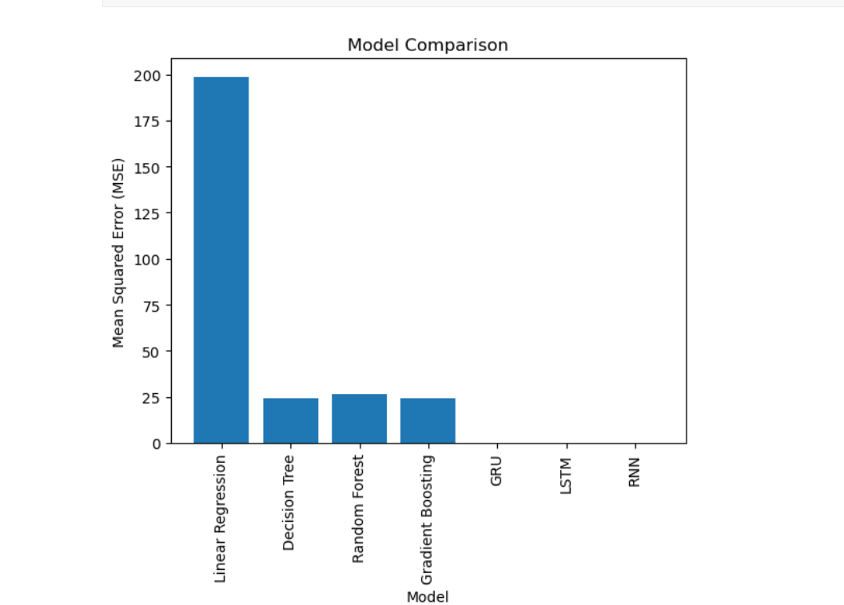

Simple RNN MSE: 0.008877523996036685

LSTM MSE: 0.0008769432293824911

GRU MSE: 0.005140174885601734

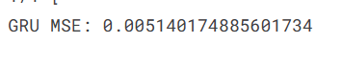

# Water Treatment

## DNN

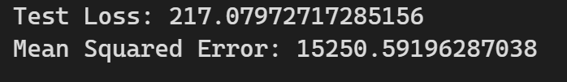

# Water Leak

***Acceleromter:***

Branched: Dnn loss: 0.3361 - accuracy: 0.8810328056710373

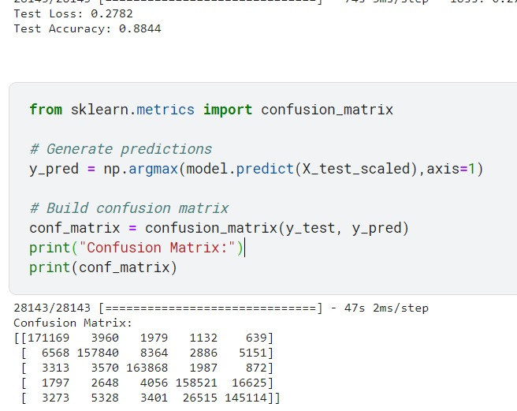

Looped: Dnn



***Hydrophone:***

Branched: Dnn

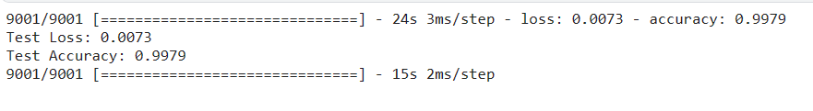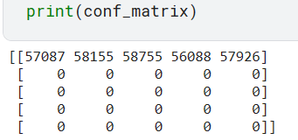

Looped: Dnn

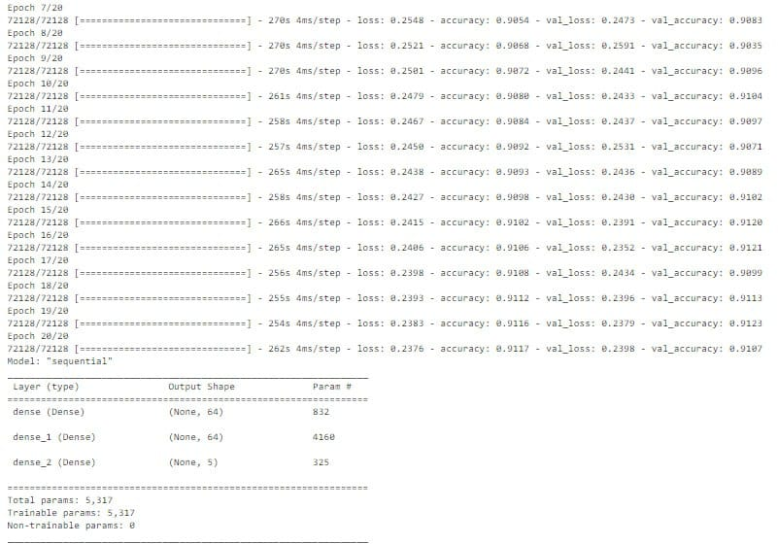

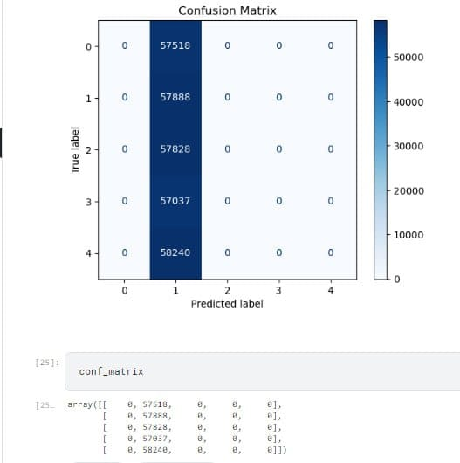

***Pressure:***

Branched: Rnn

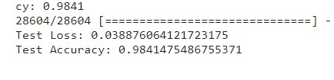

Looped: Dnn

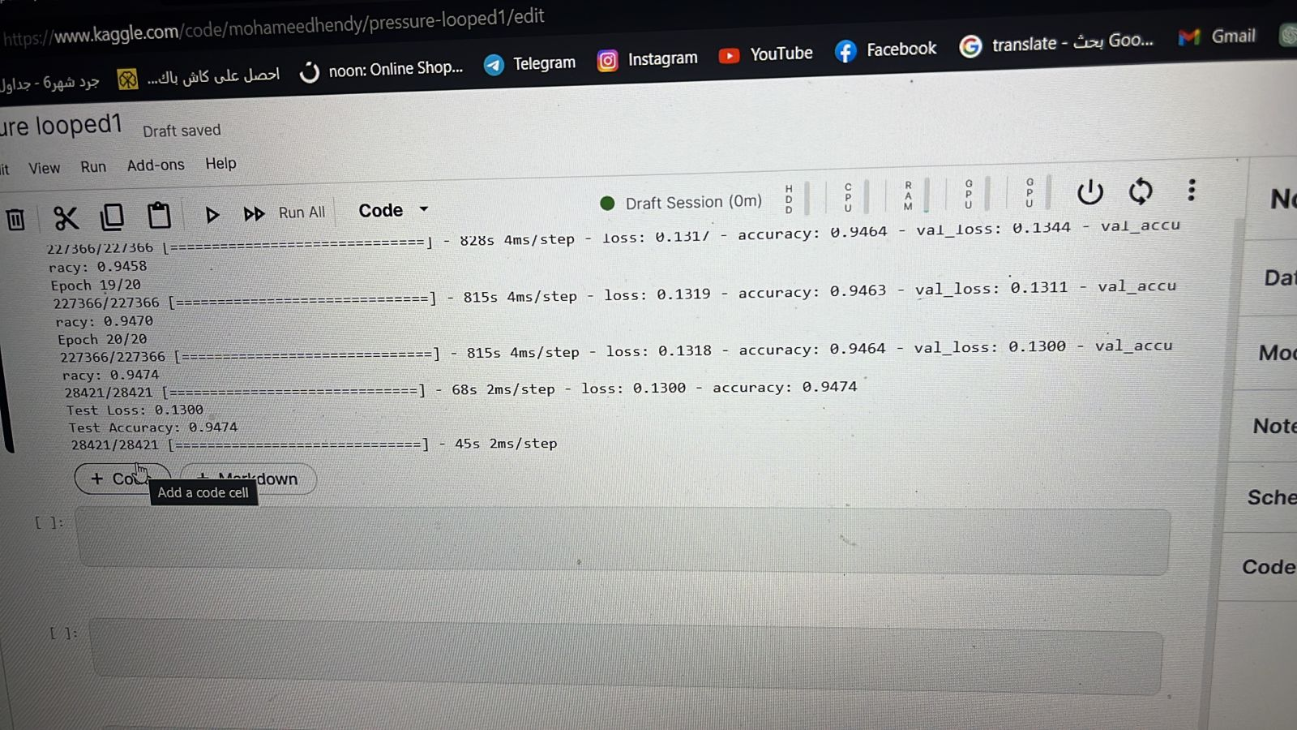

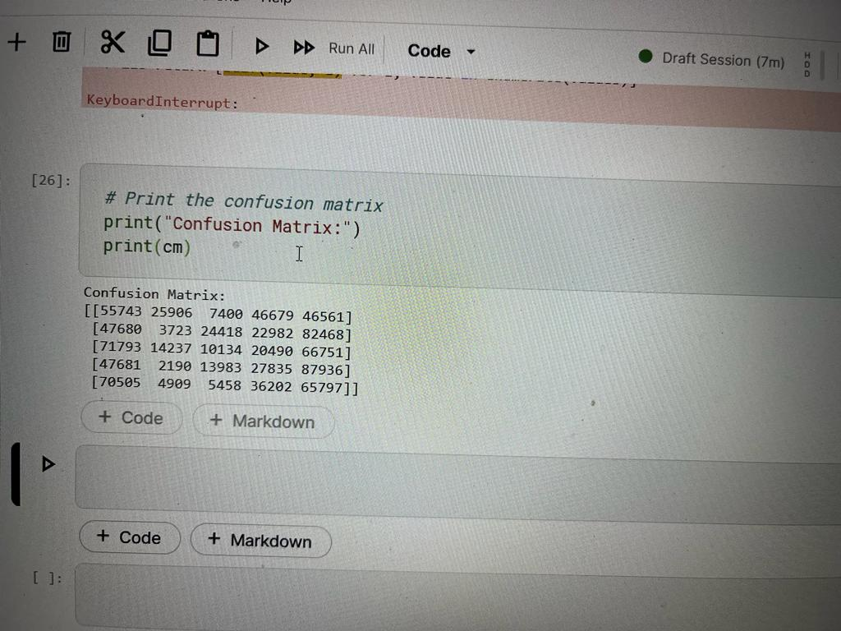

# **Predict Water Consumption**

## Tank 1: LSTM



## Tank 2: LSTM

